61st Cardiff Scout Group –
Vehicle Loan Form
Organisation Details:
Organisation Name:
Organisation Address:

Responsible Person Name:
Responsible Person Role:
Responsible Person Contact Number:
Responsible Person Email Address:
Are they aware of the loan?

Driver 1 Details:
Driver Name:
Driver Address:

Driver D.O.B:
Driver Contact Number:
Driver Email Address:
Driver Driving Licence Number:
Driver Driving Licence Expiry Date:
Driver Penalty Points:
Does the driver hold a D1?
Is the driver being paid to drive?
Are the passengers paying for the transport?

Driver 2 Details:
Driver Name:
Driver Address:

Driver D.O.B:
Driver Contact Number:
Driver Email Address:
Driver Driving Licence Number:
Driver Driving Licence Expiry Date:
Driver Penalty Points:
Does the driver hold a D1?
Is the driver being paid to drive?
Are the passengers paying for the transport?

Page 1 of 4
Vehicle Details:
Make:
Model:
Colour:
Registration Number:
Number of Seats:

Loan Period:
Collection Date:
Collection Time:
Return Date:
Return Time:
Loan Period (Number of Days):

Vehicle loan terms:
- Our vehicles cannot be used for hire or reward. You must not charge for its use or be paid for driving the vehicle.
- All drivers must be over the age of 21 years.
- The vehicle is to be returned with the same or more fuel than when you collected it. No payment will be made for any additional fuel the vehicle is returned with.
- Any damage to the vehicle must be reported immediately.
- Any fines incurred during the hire period will be charged to the organisation responsible for the loan period.
- In the event of the vehicle being damaged and an insurance claim being made on our policy, the organisation responsible for the hire period will be charged any excess charge incurred by 61st Cardiff Scout Group.
In the event of an accident or breakdown:
- Please advise a member of 61st Cardiff Scout Group. (Contact: Neil Whittington 077920 30017, and if not available Contact: Ashley Halton 07790 889642 or Chris Williams 07751 683271)
- Vehicle insurance is held with “QBE” via “Unity Scout Insurance Services”. Claims will be reported by 61st Cardiff Scout Group however for information only Unity Scout Insurance Services can be contacted on 0345 040 7703 and QBE on 0808 1008181. The Policy Number is 00021245MBP.
- Breakdown cover is provided by the AA, their breakdown number is 0800 887766.
*Please print, sign and date below to confirm you have received, read and understand all of the above.
Drive 1 Print Name:
Driver 1 Sign:
Driver 1 Date:

Drive 2 Print Name:
Driver 2 Sign:
Driver 2 Date:

Page 2 of 4
Vehicle Collection:
*Please list and describe any damage, dents or scratches larger than a 50p piece below and note the corresponding number on the vehicle image below.
1:
2:
3:
4:
5:
6:
7:
8:
9:
10:
11:
12:
13:
14:
15:
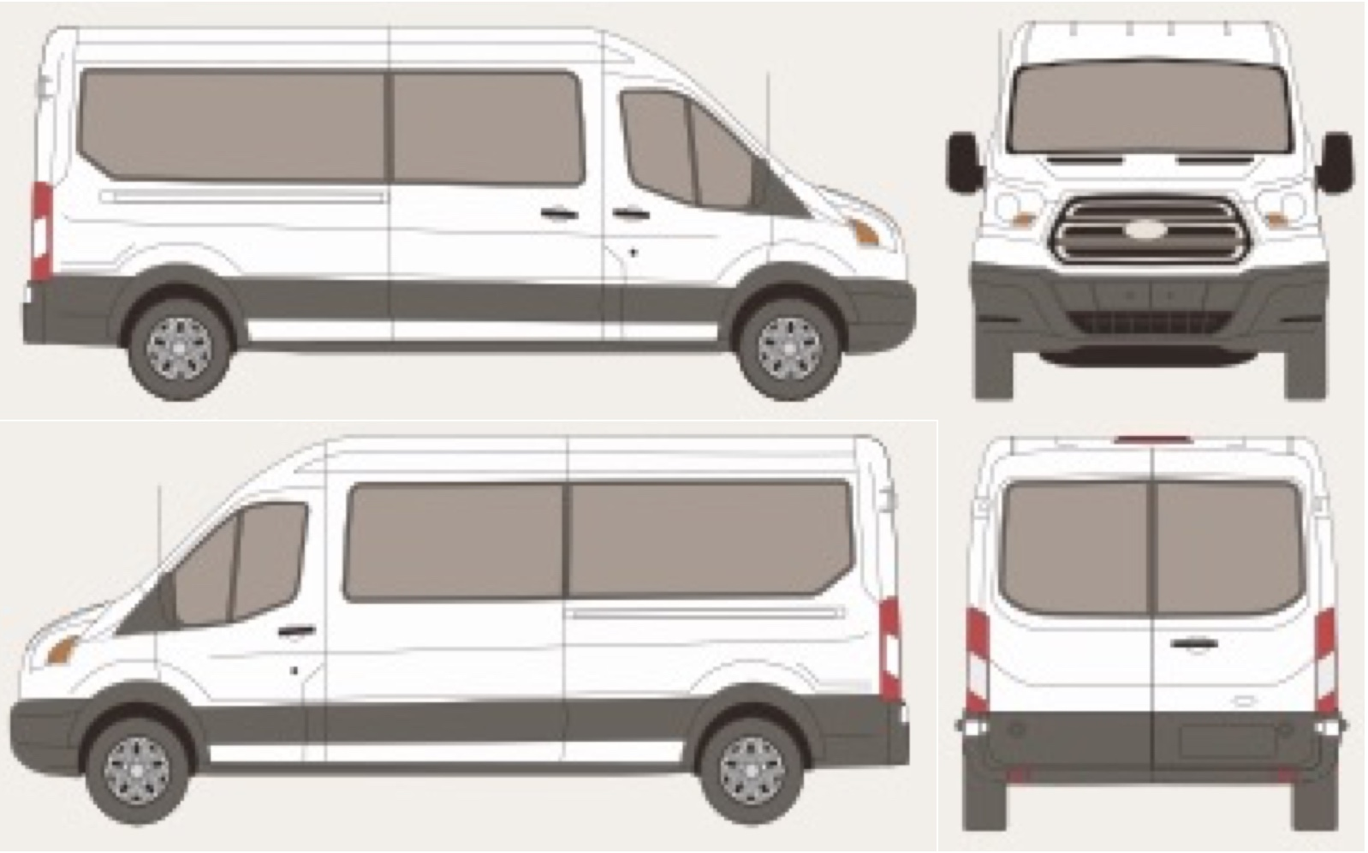
Collection Mileage:
Collection Fuel Level:
Name of person collecting:
Signature of person collecting:
Date of signature:

Page 3 of 4
Vehicle Return:
*Please list and describe any damage, dents or scratches larger than a 50p piece below and note the corresponding number on the vehicle image below that where not present at collection.
1:
2:
3:
4:
5:
6:
7:
8:
9:
10:
11:
12:
13:
14:
15:
Return Mileage:
Return Fuel Level:
Name of person returning:
Signature of person returning:
Date of signature:

Page 4 of 4

